Level 5 State Championships
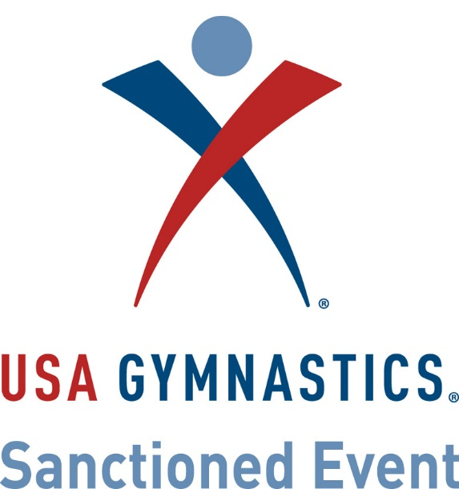
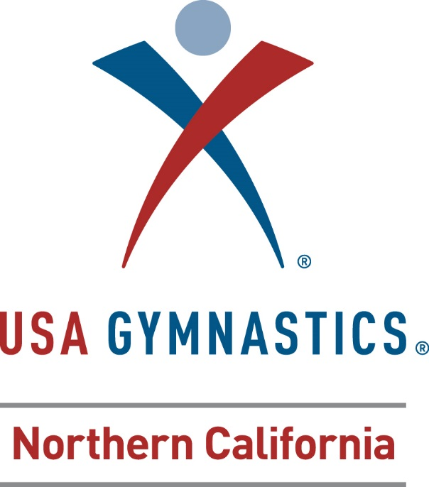
ENTRY FORM

November 5-6, 2016

Fill out and send to: Oroville Gymnastics
Attn: Heidi Wensel
1875 Feather River Blvd, Oroville, CA 95965
Email: heidiwensel@sbcglobal.net or (530)354-6961
Information will be posted on our web site at www.orovillegymnastics.com.

CLUB INFORMATION
Club Name:_____________________________________________________________
Club Number:_______________________ Phone:_____________________________
Street Address:_____________________________Fax:__________________________
City:__________________________________State:__________Zip Code:___________
Contact Person:__________________________Contact Phone:_____________________
Contact e-mail address:_____________________________________________________
COACH INFORMATION
NAME | USAG NO. | USAG EXP | SAFETY EXP | BKGRND EXP

GYMNAST INFORMATION
NAME | USAG# | DOB | T-SHIRT Y/N

Number of gymnasts:________ Cost per gymnast: $85.00 with t-shirt coupon ($75 if no t-shirt coupon) Total:____________ Please make checks payable to OGBC (Oroville Gymnastics Booster Club)

